- Following a tough period for UK consumers, we expect consumption to recover this year. Growth in incomes will be the main driver, but an appetite to borrow more and save less should also help.
- That said, still-high interest rates, the drag from inflation on the purchasing power of households' savings and possible scarring from the recent economic shocks could limit the boost from dissaving.
- We think an improved financial outlook, stronger consumer sentiment, and households' relatively low debt levels will support the recent rebound in consumer borrowing. But higher interest rates and what seems to be a level shift in repayment rates for unsecured debt offsets these positives.
- Households appear to be still holding substantial excess savings that they accumulated during the pandemic, though that savings firepower looks less formidable after adjusting for inflation. Still, historical norms suggest households have scope to save less – a prospect that interest rate cuts and a more stable macroeconomic outlook should support.
We recently argued that the prospect of a quicker decline in inflation increases the chances of a consumer-led recovery, fuelled primarily by growth in real household incomes. We also expect some support from two other drivers of consumption – households' appetite to take on unsecured debt and to save less.
Over the next few years, we forecast growth in consumer spending will slightly outstrip rises in income, with dissaving making up the difference. Support from this source is unlikely to trigger a fully-fledged consumption boom, however (Chart 1).
Chart 1: We expect dissaving to provide modest support to consumption over the next few years
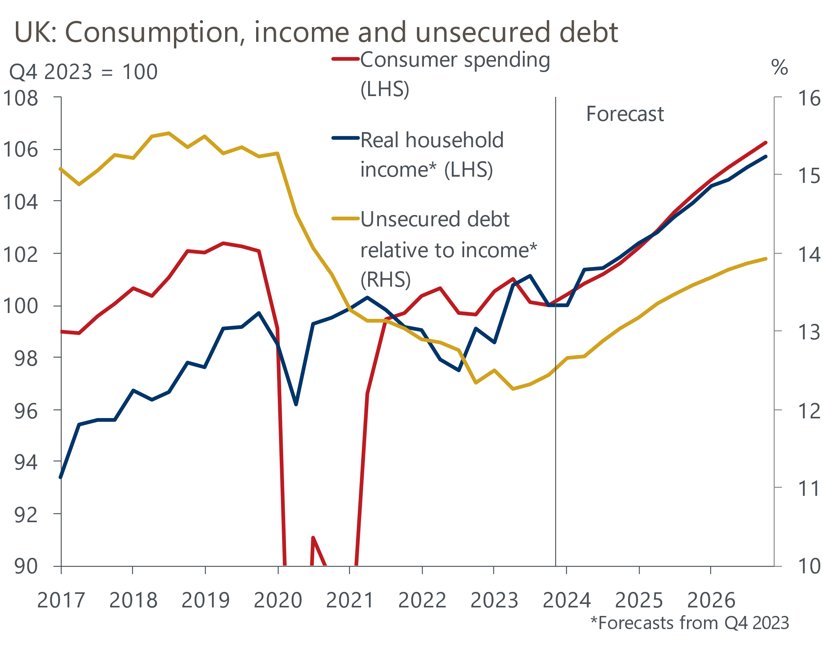
Source: Oxford Economics/Haver Analytics

Strong growth in consumer credit has been flattered by high inflation
Growth in consumer credit, which includes lending via credit cards and personal loans, appears to have been a tailwind to consumer spending in 2023 – at least on the surface. In net terms, lending rose 6.1% last year, the fastest increase since 2017 and well above growth of 2.4% averaged between 2010 and 2019.
But the rise in consumer credit in 2023 was flattered by the effect of high inflation in pushing up the average spend per transaction. After adjusting for inflation, net lending to consumers in fact fell 1.2% in 2023, the fourth successive annual real terms drop.
Still, 2023's real terms decline was the smallest over that four-year period. And on a monthly basis, year-on-year growth in real consumer lending returned to positive territory in the second half of 2023 for the first time since early 2020 (Chart 2).
Chart 2: Consumer credit has recently been growing again in real terms
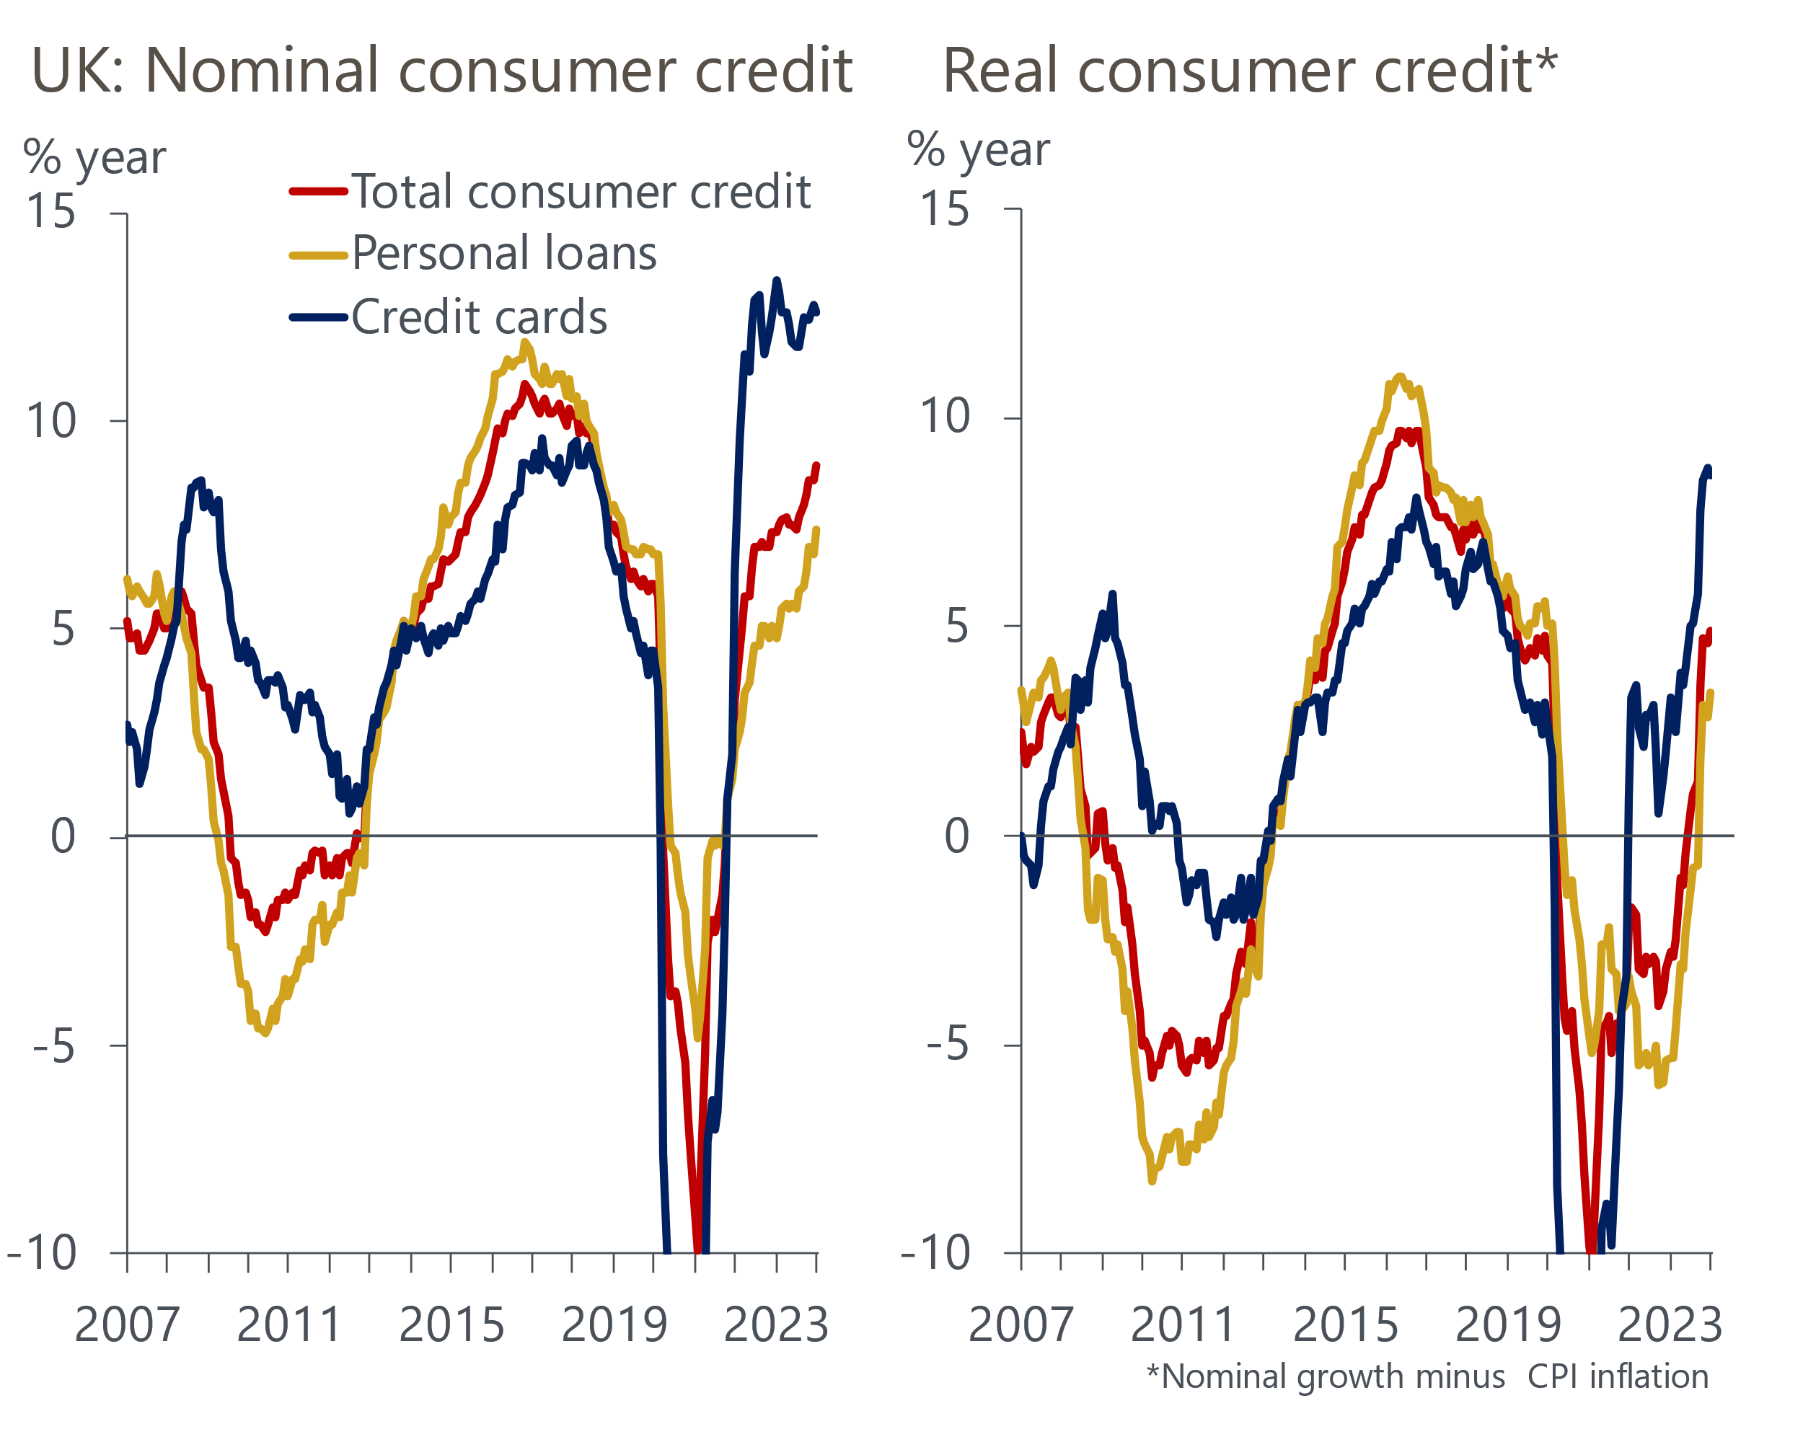
Source: Oxford Economics/Haver Analytics

The recent return to real-terms growth in credit may be sustained
According to the Bank of England, this recovery may have been supported by an increasing proportion of credit cards issued in short-term teaser deals at 0% interest. A better financial outlook for households could also have played a role. The inflationary shock of the last few years has been receding, pay growth is now outstripping price rises, and pressures on households from energy and food prices – the most tangible elements of the recent cost-of-living crisis – have dropped back. There may also be a compositional effect at play – surging energy bills, which tend not to be paid for with credit cards, have squeezed discretionary spending, where the use of credit cards is more common, in recent years. This effect is now reversing as energy bills fall.
Meanwhile, an improved financial outlook has underpinned a recovery in consumer sentiment, another factor that may have translated into a greater willingness to take on unsecured debt. Though GfK's measure of consumer confidence remains some way below the long-run average, it's bouncing back from the historically low levels in 2022 and 2023.
A third support to credit demand is the relatively healthy aggregate financial position of households, meaning consumers should have fewer concerns about taking on more debt. Deleveraging during the pandemic plus strong wage growth in recent times has resulted in the stock of unsecured debt falling to 12.3% of annualised household income, the lowest since 1996 (Chart 3).
Chart 3: Households' debt burdens have fallen in the last few years
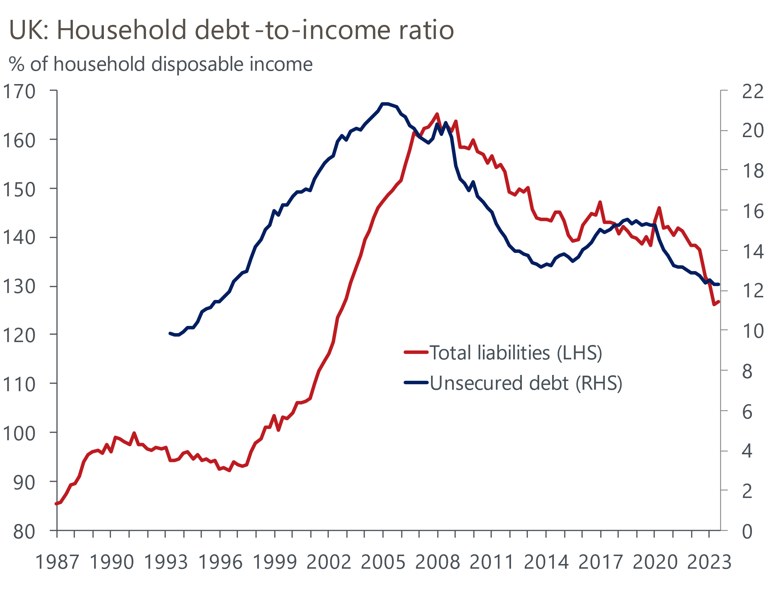
Source: Oxford Economics/Haver Analytics

Higher interest rates and economic shocks may have shifted attitudes to debt
Relatively low debt levels provide a foundation for households to leverage up before confronting potential balance sheet constraints, although if we take the unsecured debt ratio of the last decade as reflecting the 'steady state', the room for debt to rise is more limited than a longer sweep of history might suggest.
But the recent direction of travel in household debt may also be a sign that households want to hold fewer financial liabilities than in the past. The higher cost of unsecured borrowing could be one motive for such a shift in attitudes. As of January 2024, borrowing rates on personal loans were 350bps-400bps higher than the recent lows of 2021, though a less severe 150bps higher than the 2010-2019 average.
Borrowing on credit cards has become particularly expensive. Unlike the cost of personal loans, average rates on credit cards rose during the pandemic, despite interest rate cuts by the BoE, and reached a record high of 24% last December. This was around 600bps higher than the 2010-2019 average (Chart 4).
Chart 4: The cost of unsecured borrowing has jumped over the last two years
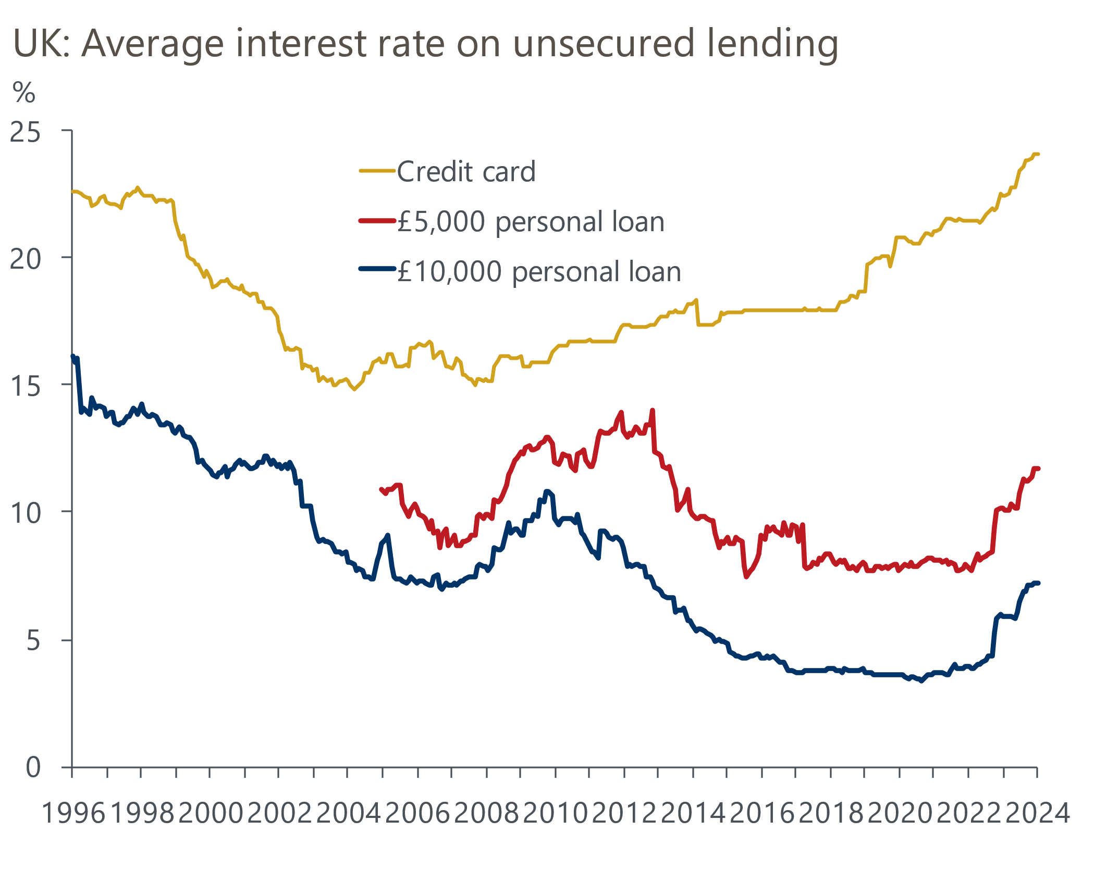
Source: Oxford Economics/Haver Analytics
The higher cost of credit card lending may help to explain a big rise in the rate at which credit card debt is repaid. From 2013-2019, monthly repayments of credit card debt averaged the equivalent of 23% of the stock of credit card borrowing outstanding in the previous month, with the share rising modestly over that period. But the repayment rate jumped during 2021 and has settled at just over 30% since early 2022. The repayment rate for personal loans also increased, but to a much more modest extent (Chart 5). Since it's the net addition to unsecured lending that adds to household resources and spending power, what appears to be a persistently higher repayment rate could blunt any boost to consumption from credit growth.
Chart 5: Consumers have been repaying credit card debt at a much higher rate than in the past
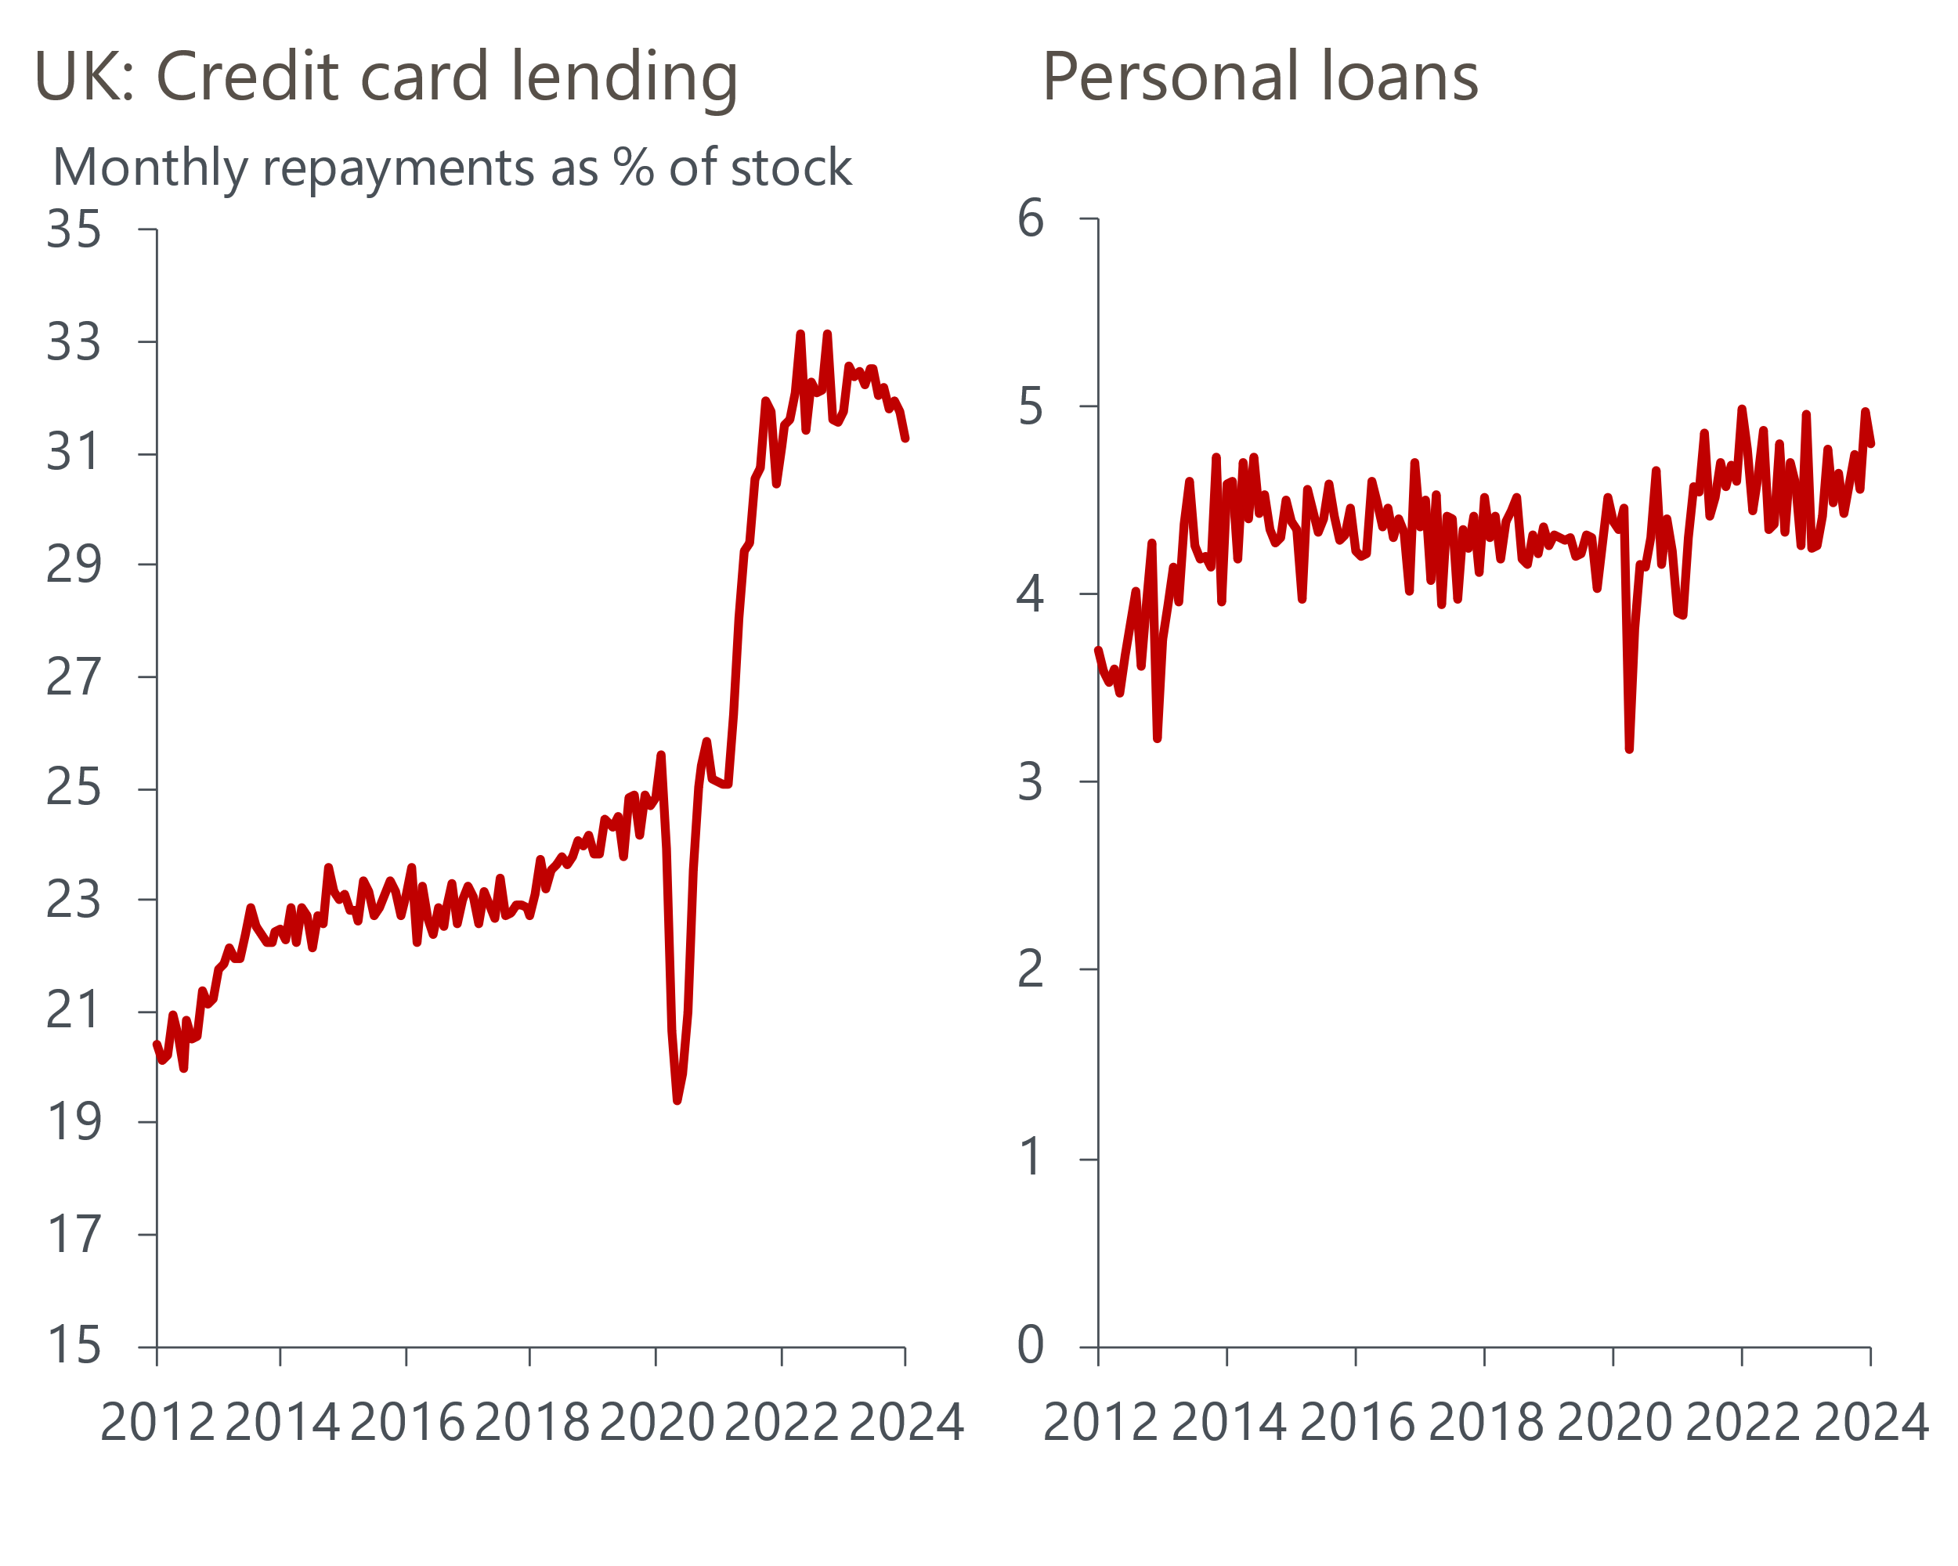
Source: Oxford Economics/Haver Analytics
Psychology may also be playing a role. A more uncertain economic environment raises the incentive to keep debt levels down. And amid cost-of-living pressures, consumers' may have increasingly wised up to the relatively high cost of credit card lending – still willing to use credit cards for perks such as cashback and air miles, but seeking to repay balances more quickly than in the past. A structural decline in the use of cash triggered by the Covid pandemic is another possibility, with more people now using credit cards for the sort of small value transactions they would previously have used cash for.

Households still hold large 'excess' savings, in nominal terms at least
A further potential reason for the rise in repayments is that consumers, in aggregate, are in a better position to repay credit card balances quickly because of the pandemic-era rise in savings.
We've previously set out two different approaches to measuring the 'excess' savings accumulated during that period, as lockdowns limited opportunities to spend and household incomes remained resilient. One compares the savings ratio to its 'normal' level, calculated from both a 2010-2019 average and just the 2019 rate, and a second uses household deposits.
On both measures and as of Q3 of last year, households appear to still be sitting on substantial excess savings (Chart 6). Alongside a recovery in consumer credit, scope to draw on these savings offers another channel through which dissaving could support consumption.
Chart 6: On various measures, households still have most of the savings built up during the pandemic
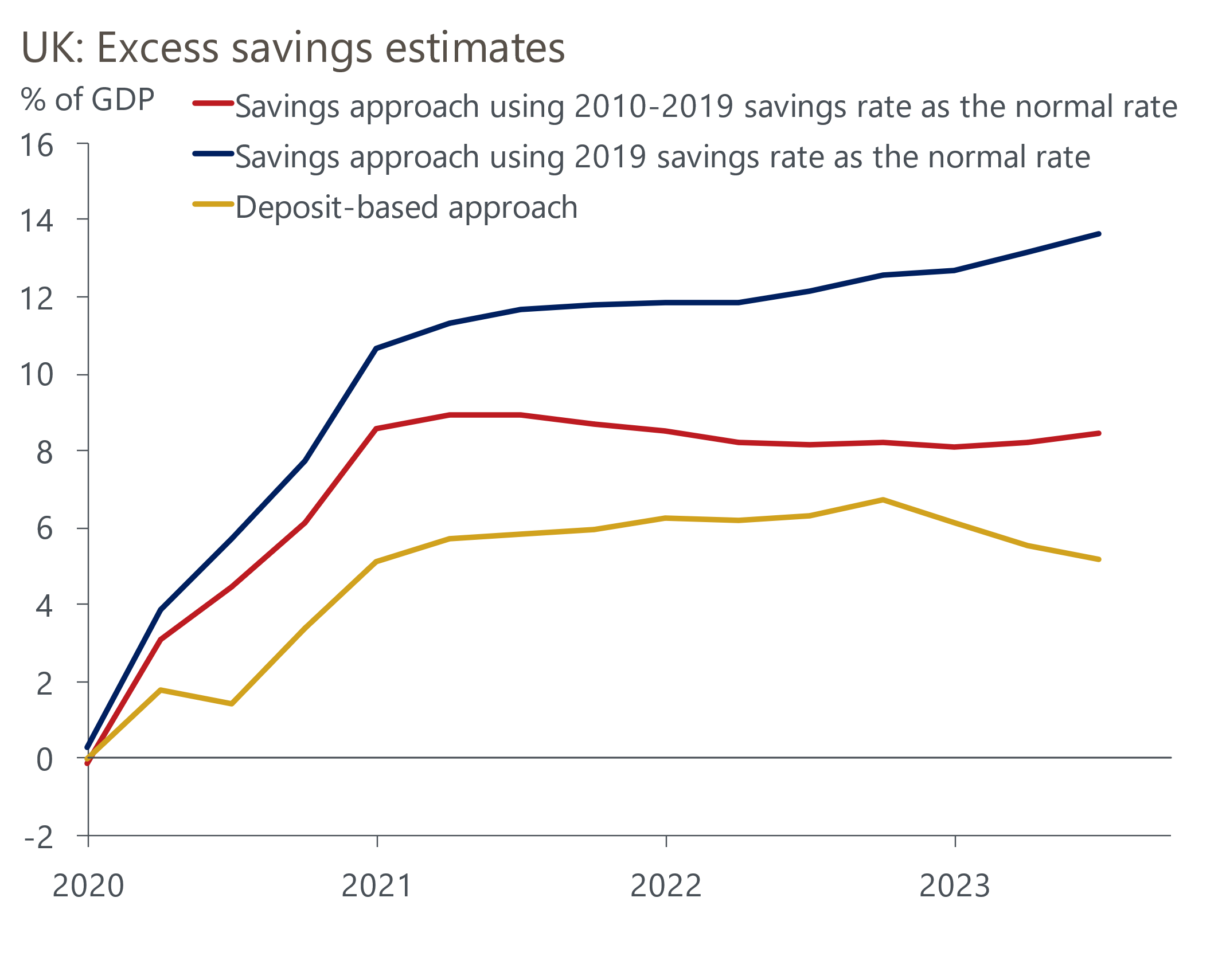
Source: Oxford Economics calculations using data from Haver Analytics

Adjusting for rising prices, savings firepower looks more limited
Since the headline saving ratio includes changes in pension entitlements, however, it's not a perfect guide to what most people would consider 'savings'. And the effect of inflation means the potential fuel for spending offered by even a purer measure of day-to-day savings isn’t as great as it might appear. In nominal terms, households' holdings of cash and money in bank accounts in Q4 2023 stood at £1.8tr. This was around £110bn above what a continuation of the pre-Covid 2010-2019 trend would have implied, an apparently hefty war chest.
But the high inflation of 2022 and 2023 has eroded the purchasing power of those savings. Expressed as a share of nominal consumer spending, households' liquid assets surged during 2020 and early 2021, rising from the equivalent of 107% of annualised consumption in Q4 2019, to a peak of 145% in the first quarter of 2021. But the ratio has since fallen, dropping to 114% in Q4 2023 (Chart 7).
Chart 7: Households' liquid assets relative to consumption have fallen back since 2021
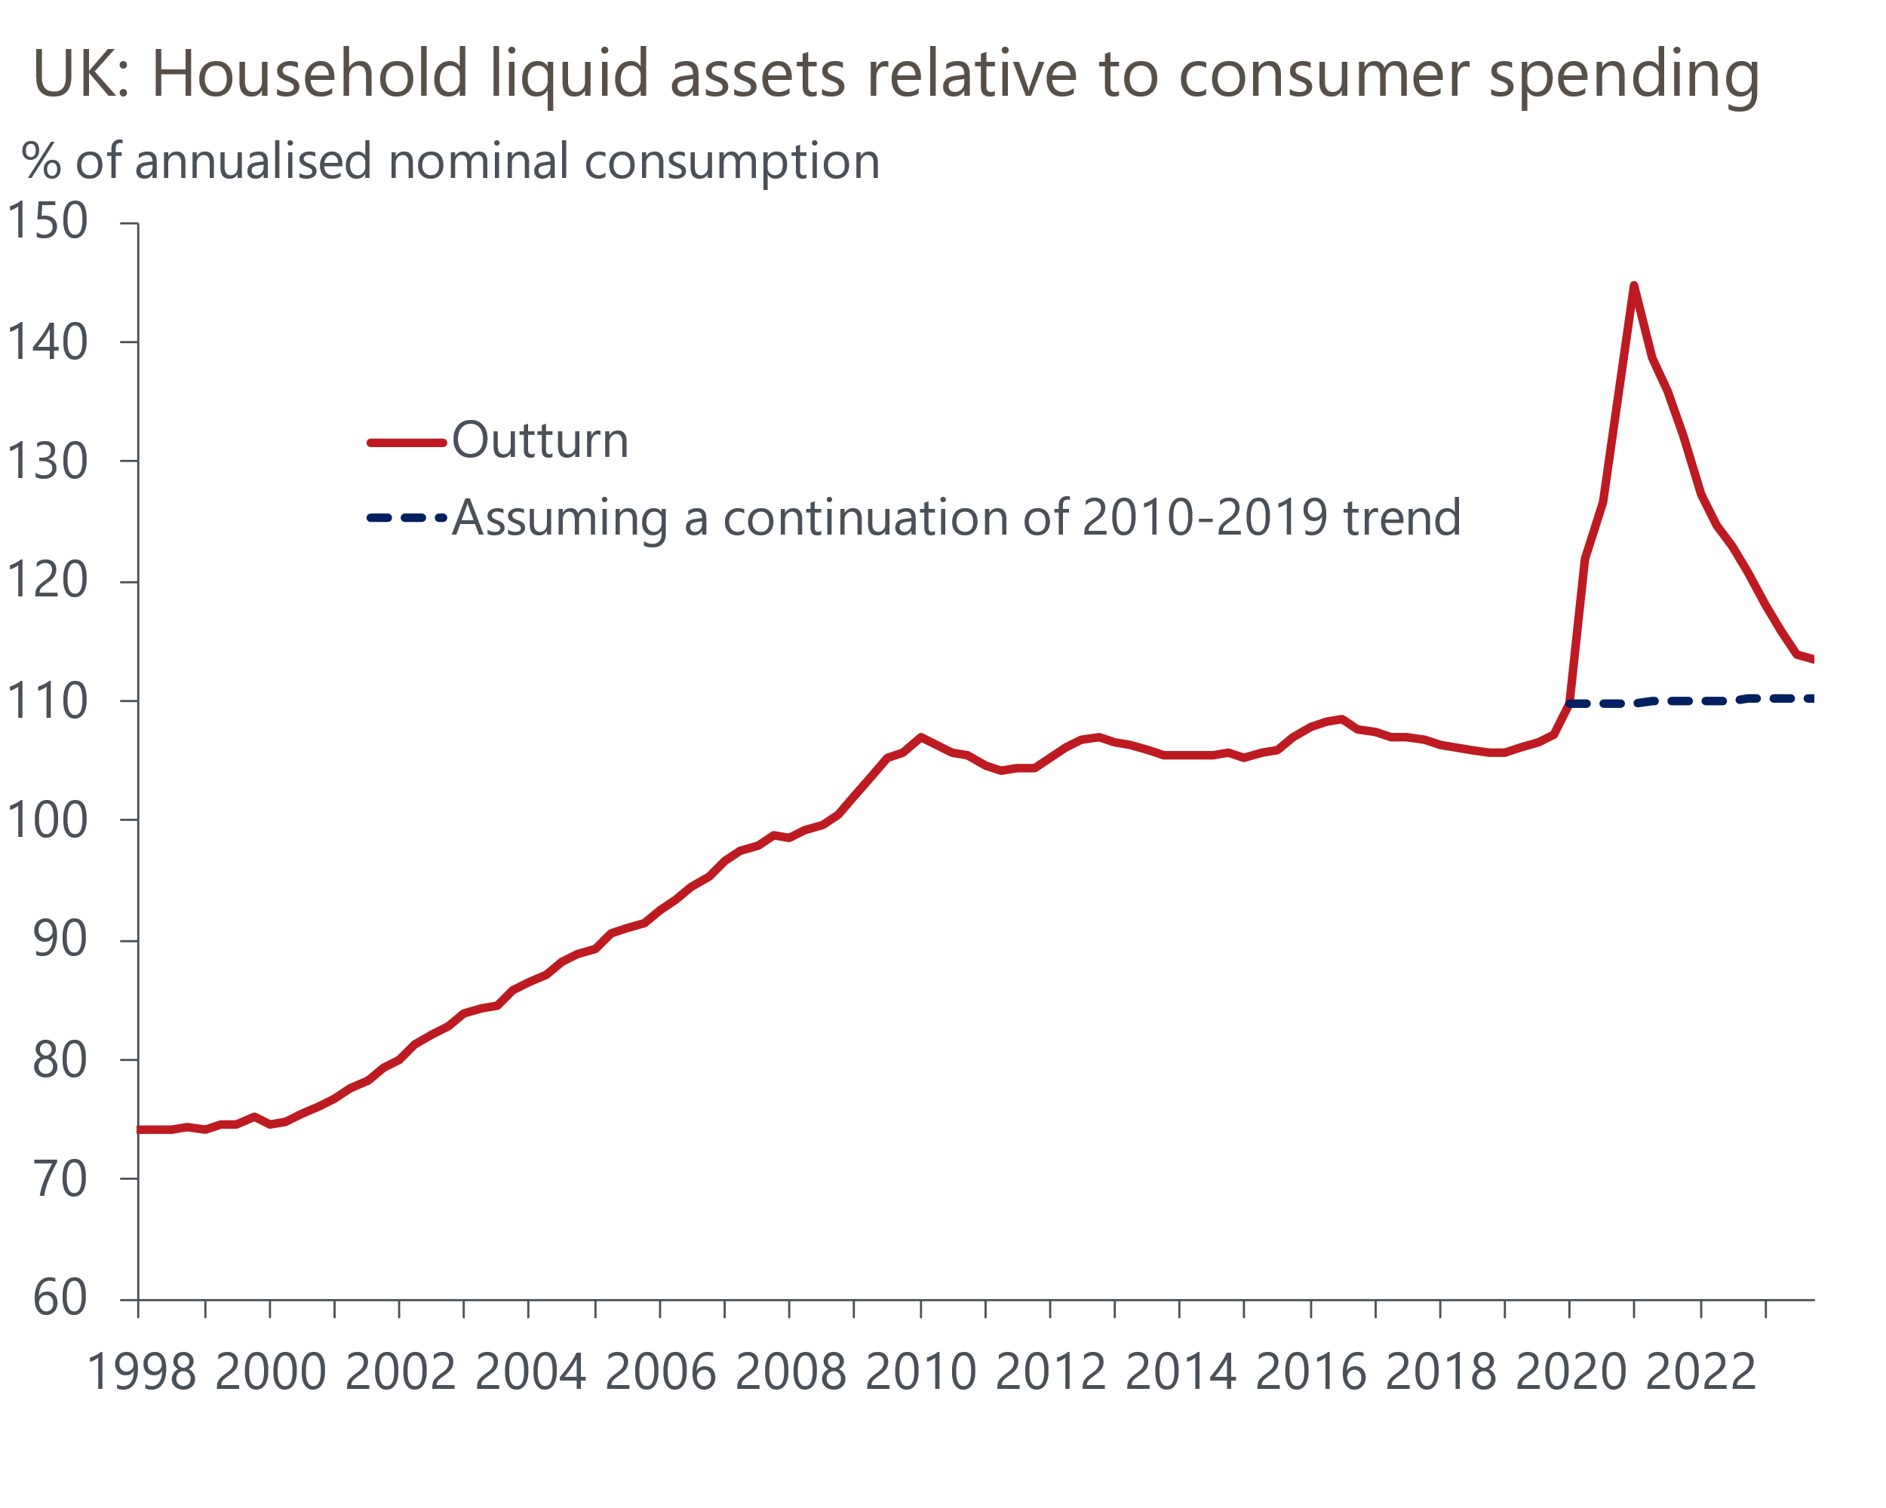
Source: Oxford Economics/Haver Analytics
Still, the ratio is a little above both pre-Covid levels and what a continuation of the pre-Covid trend would imply, indicating some room for dissaving versus past norms. This tallies with Hargreaves Lansdown's latest savings and resilience barometer – developed in conjunction with Oxford Economics – which found that overall household financial resilience late last year was still above 2019 levels.
What's more, there are reasons why households may want to hold fewer liquid assets than past patterns would suggest. The prospect of interest rate cuts this year will reduce the opportunity cost of spending rather than saving. It may also mean some borrowers, who had anticipated that the BoE rate would stay higher for longer, feel less need to save more to try to better absorb the higher payments due when their previous fixed rate mortgage deals expire.
A return to low inflation and a more stable macroeconomic environment following the shocks of the last few years also means some households may feel less need to save for precautionary reasons. The likelihood of a soft landing for the housing market versus previous predictions of a sharp correction could work in the same direction, at least for mortgagors.
As a result, our forecast anticipates some support to consumption over the next few years from a decline in the savings ratio. But we've long been cautious on the scope for less saving to deliver a major boost to consumption, not least because of the concentration of savings among better-off households. And that caution is reinforced by the corrosive effect of recent high inflation on just how much of a bang-for-the-buck savings accumulated in the past can deliver.

A revival in consumer spending is key to our GDP forecast
A combination of some positives for household incomes, primarily lower inflation, and some dissaving mean we expect consumer spending growth to gather momentum this year, although carry-over effects from the fall in consumption in H2 2023 will hold back calendar-year performance in 2024. We forecast growth in consumer spending will pick up from 0.3% in 2023 to 0.6% this year and 2.2% in 2025.
In our forecast, this gradual revival will more than account for the entirety of GDP growth over this year and next, offset by a negative drag on growth from investment, government consumption, and net trade combined.
It follows that if our forecast proves accurate, risks to consumption, both to the up- and downside, could bear heavily on the economy's overall performance. But at least the prospect of consumer-led growth in the near-term doesn't carry the sort of concerns about imbalances and excesses seen in past consumer revivals. We don't anticipate consumption regaining its pre-Covid level of Q4 2019 until the first quarter of 2025, while households' unsecured debt burden will pick up, but remain low by past standards. So overall, we expect a consumer recovery, but not a boom.

